* Create virtual hosts mapped to the domain names webtech2.access.org
* In the document root of these virtual hosts, create a dummy file named index.html.
* Configure access to these virtual hosts such that:
* Only requests from host with *.edu or *.org domains will be allowed
* Only GET, HEAD, and POST requests will be allowed
* POST requests will be allowed only for valid users authenticated via basic authentication, using the ID numbers of the group’s members as user credentials (i.e., usernames and passwords)

Step 1: Confirm that Basic Authentication is installed

## 

## Step 2: Enable Basic Authentication IIS

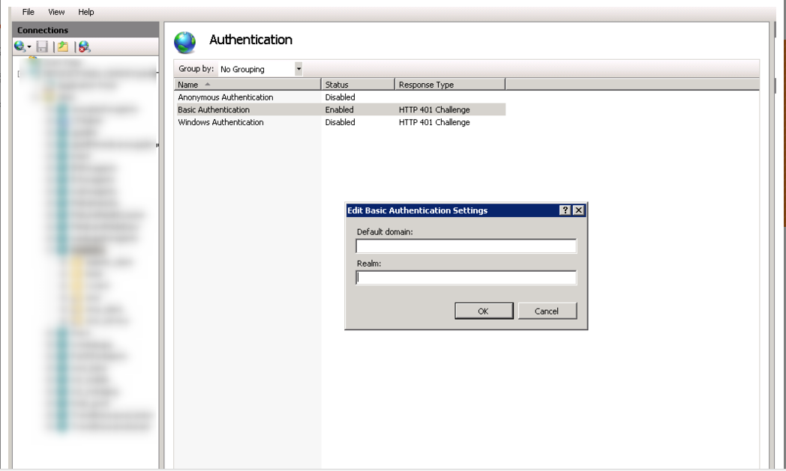

## Step 3: Create a Virtual Host

Open IIS

Right click the Site tab

Click add website

Enter a site Name [www.webtech2.access.org](http://www.webtech2.access.org)

Create a dummy file named index.html

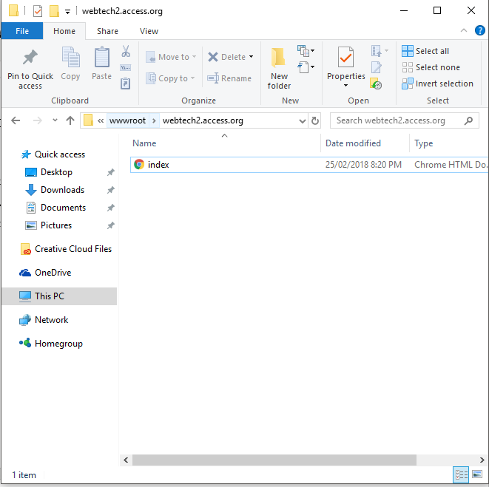

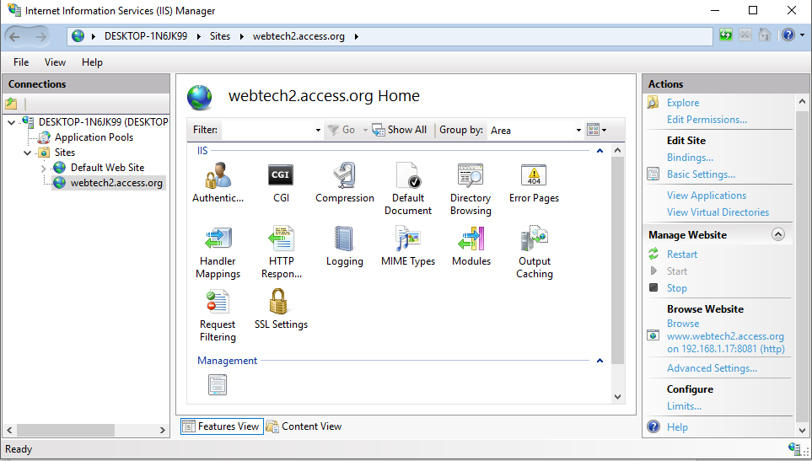

1. On the Authentication page, select Basic Authentication.
2. In the Actions pane, click Enable to use Basic authentication with the default settings.
3. Optionally, in the Actions pane, click Edit to type the default domain.
4. In the Edit Basic Authentication Settings dialog box, in the Default domain text box, type a default domain or leave it blank. Users who do not provide a domain when they log on to your site are authenticated against this domain.
5. In general, you can use the same value for the name as you used for the default domain.
6. Click OK to close the Edit Basic Authentication Settings dialog box.

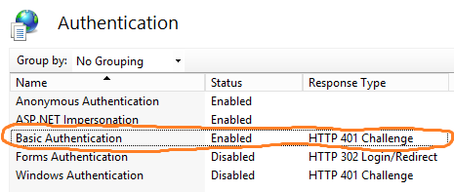

## Step 4: Verify Setting Changes

Launch up your web browser, navigate to the website and see if it prompts for a logon. If it does, you correctly enabled basic authentication. At this point if it rejects your username and password do the following.

1.) Confirm Username and Password are correct   
2.) Make sure the User being used has access to the websites files.